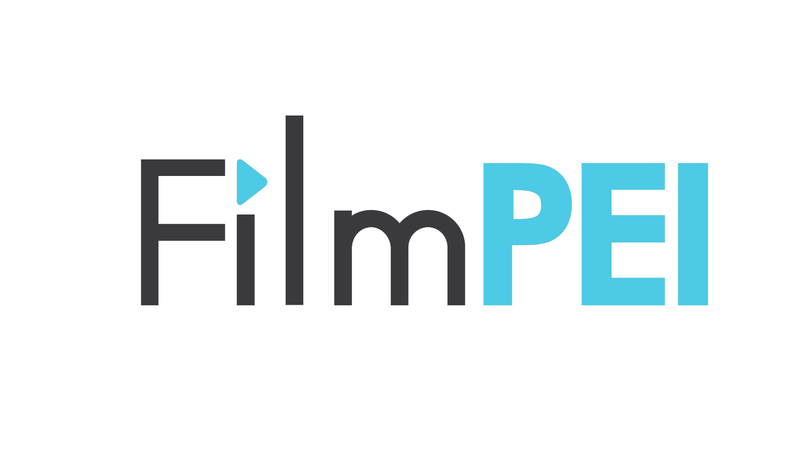

**Canadian Media Fund** “Early-Stage Development Program”

FILM PEI “Letter of Interest” APPLICATION

DEADLINE 5PM - JUNE 12, 2019 (no extensions)

New this year! FilmPEI can provide up to TWO letters of interest to trigger the [CMF Early-Stage Development Program](https://www.cmf-fmc.ca/en-ca/programs-deadlines/programs/early-stage-development-program) which allows producers funds to pre-develop projects in the genres of Drama, Children & Youth, Documentary or Variety and Performing Arts. [(see definitions of eligible and ineligible projects)](https://www.cmf-fmc.ca/getattachment/a092a446-be98-4503-add8-f8bb058da775/Appendix-A-Definitions-and-Essential-Requirements.aspx)

The CMF will pay for up to 84% of the early-stage development and the producer will be responsible for the remaining 16%. REMEMBER that should the project go into production THESE FUNDS MUST BE PAID BACK ON THE FIRST DAY OF PRINCIPLE PHOTOGRAPHY.

To apply through Film PEI, we require all members to be in good standing. An Advisory Committee of industry professionals will be scoring each eligible application on four criteria:

1. ***Creative*** --- is the concept and story strong enough to warrant substantial development?

2. ***Impact*** ---- what kind of impact can this pre-development and the final project have on PEI’s burgeoning film industry?

3. ***Marketabilit****y* ---- does the project have a chance of being made?

4.  ***Feasibility*** ---- strength of team, flexibility of project to scale down to a smaller budget

**Submission Requirements:**

A) Completed **FILMPEI INTAKE FORM** (below)

B) FilmPEI **REQUIRED DOCUMENTS** in PDF format

• Signed writer(s) agreement

• Project information document (can be put all in one document)

•Title: (maximum 60 characters)

• Original Linguistic Market

• Author Name of Original Work (if applicable)

• Synopsis (2000 characters or less)

• Material to be delivered for this Application - provide a list of

the creative material that will be delivered to the presenter and the CMF as part of the development activities that are the subject of this funding application. (2500 characters or less[) SEE Eligible Costs](https://www.cmf-fmc.ca/getattachment/ad7b6c59-b120-442b-a431-826bd72dc77b/Early-Stage-Development-Program-Guidelines.aspx) (scroll to “Creator Collaboration Access Point” in the document)

• Key Personnel

NOTE: see CMF guidelines [(see link)](https://www.cmf-fmc.ca/getattachment/74e8a939-0777-4144-89be-6215492278d6/Required-documents-Data-entry-guide-(1).aspx) for a comprehensive list when applying to them for funding. Should you be granted a letter of interest from FilmPEI and are successful in your funding application to CMF you will be required to incorporate a company before they will release the funds.

**FILM PEI INTAKE INFORMATION (required)**

• Project Name:

• Project Genre:

• Project Logline:

• Producer Name:

• Company Name:

• Company registered in PEI? y/n:

• Writer Name (can be the same as the Producer):

• Budget Requested:

• Financing Scenario (where will the 16% that CMF doesn’t cover come from?):

• Producer/Writer Team track record (250 words or less):

• Potential Broadcaster/Distributor (if produced, where would your final project be seen?):

• In 500 words or less please share any relevant information that might make your project stand out as a having a strong possibility of getting produced. Broadcaster interest in the property, relevant broadcaster/distributor etc. relationships, star attachments to the project,

• Add any information you feel will make your application stronger (250 words or less)

Submit applications in PDF format to [director@filmpei.com](mailto:director@filmpei.com) by 5pm, June 12th with the subject line “CMF Application”. You will receive a notice of receipt. Contact the EXECUTIVE DIRECTOR if you don’t receive such a notice.

**ONLY ELIGIBLE APPLICATIONS WILL BE FORWARDED TO THE COMMITTEE. Please note that FilmPEI will NOT be advising people of missing documents.** **Any project deemed ineligible due to missing documentation will NOT be forwarded to the committee for review.**

IMPORTANT: The applicants that succeed in acquiring a letter of interest from FIlmPEI are not guaranteed CMF funding. Successful producers will have to apply for funding to CMF via their DIGITAL PLATFORM [(DIALOGUE)](https://telefilm.ca/en/log-in) . IT IS RECOMMENDED THAT PRODUCERS PRE-REGISTER SEVERAL DAYS PRIOR TO THE JUNE 20TH CMF OPENING DATE TO ENSURE THEIR ACCOUNTS ARE SET UP AND READY FOR APPLICATION DAY.